Course Review Analyzer

The Course Review Analyzer is a web-based application designed to collect, manage, and analyze student feedback on various courses. It allows users to submit reviews including ratings and comments, and provides insights such as average rating, top-rated courses, and graphical analysis.
This system helps students make informed decisions while selecting courses and assists institutions in improving course quality.

Objectives
- To build a system for collecting course reviews
- To calculate average ratings dynamically
- To identify top-performing courses
- To visualize data using charts
- To provide a user-friendly dashboard

Scope of the Project
- Used by students to review courses
- Can be extended to colleges and online platforms
- Supports analytics for decision-making
- Future integration with authentication systems

Technologies Used
Technology |  | Purpose
Java (Spring Boot) |  | Backend development
MySQL |  | Database
JDBC | Database connectivity
HTML | Structure
CSS | Styling
JavaScript | Dynamic functionality
Chart.js | Data visualization

System Architecture

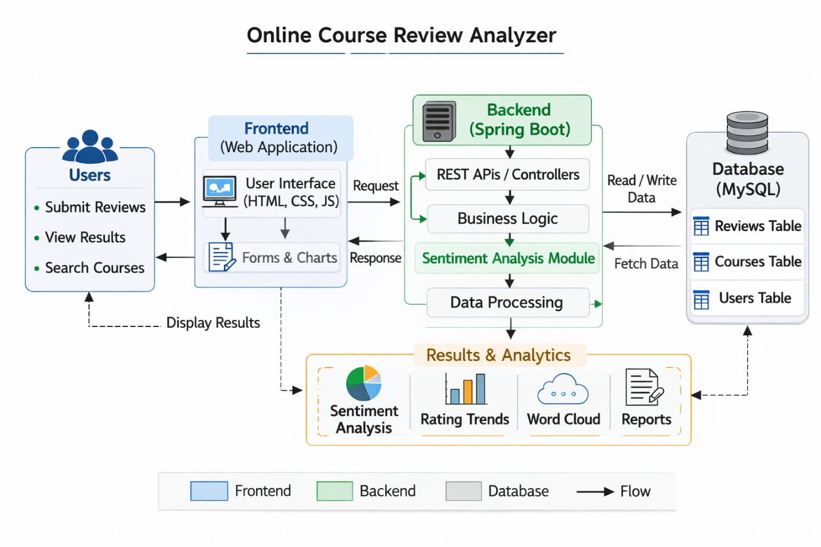

Modules Description

1. Add Review Module
- Accepts course name, student name, rating, and comment
- Prevents duplicate reviews

2. View Reviews Module
- Displays all reviews in a table format
- Fetches data from backend API

3. Analytics Module
- Calculates:
  - Average rating
  - Top course
  - Total reviews
- Displays charts using Chart.js

4. Search Module
- Allows users to search courses dynamically

Database Design
Column | Type
course | VARCHAR
student | VARCHAR
rating | INT
comment | VARCHAR

API Endpoints
GET /reviews
- Returns all reviews in JSON format
POST /addReview
- Adds a new review
- Redirects to dashboard

Working Flow
- User opens dashboard
- Submits review
- Data stored in MySQL
- Backend fetches data
- Frontend displays:
  - Table
  - Average rating
  - Charts

Features
✔ Add review
✔ Prevent duplicate entries
✔ View all reviews
✔ Average rating calculation
✔ Top course detection
✔ Search functionality
✔ Data visualization

Advantages
- Simple and user-friendly
- Real-time data analysis
- Prevents duplicate entries
- Helps in decision making

Output Screenshots
- Home page
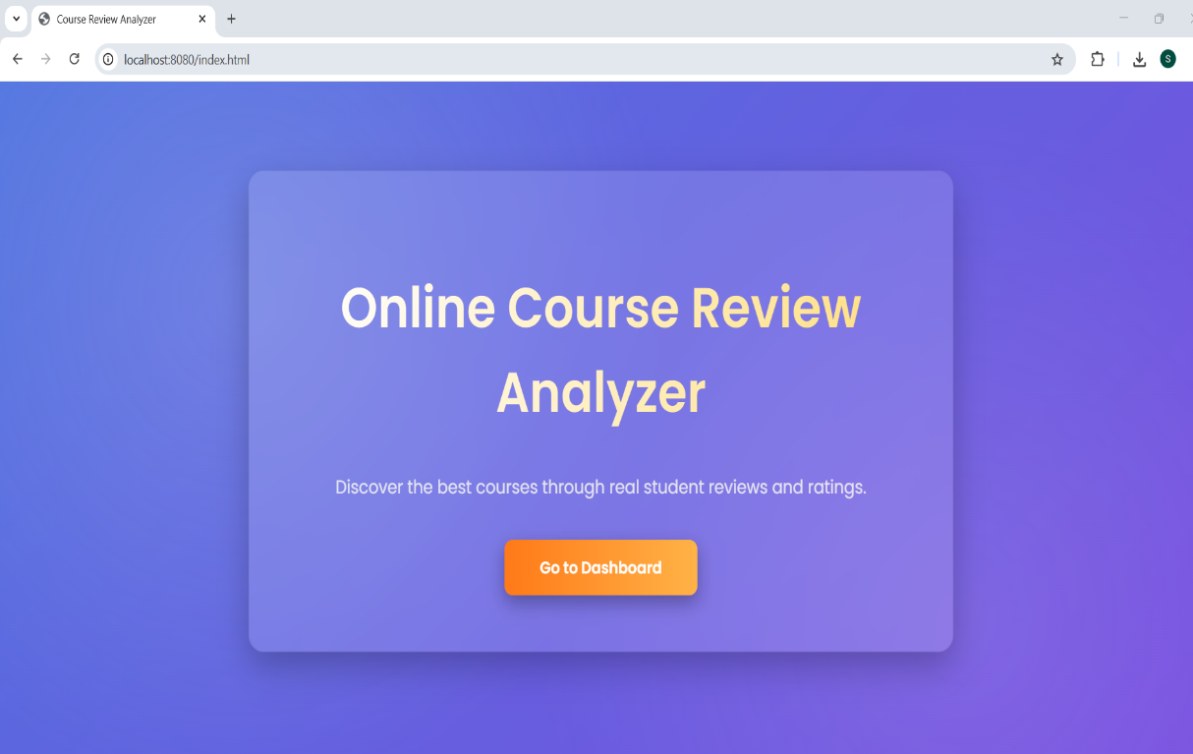

- Dashboard

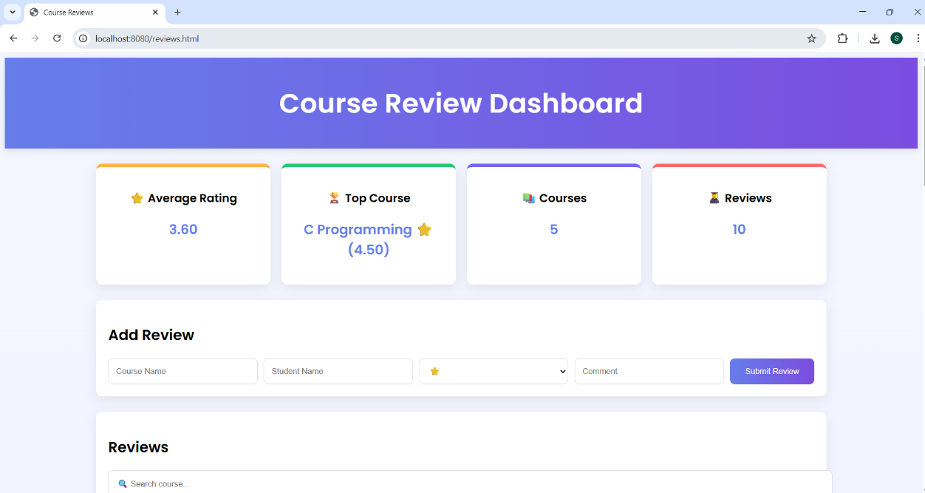
- Add Review

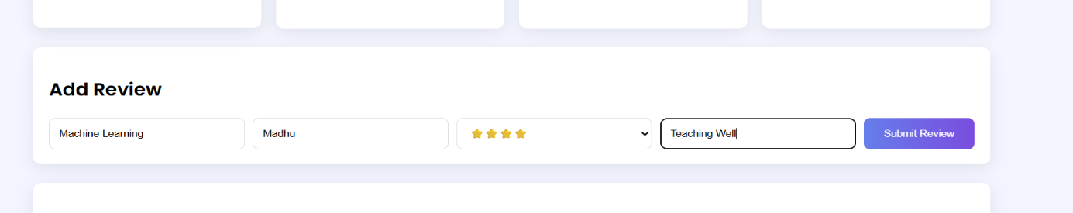
- Reviews

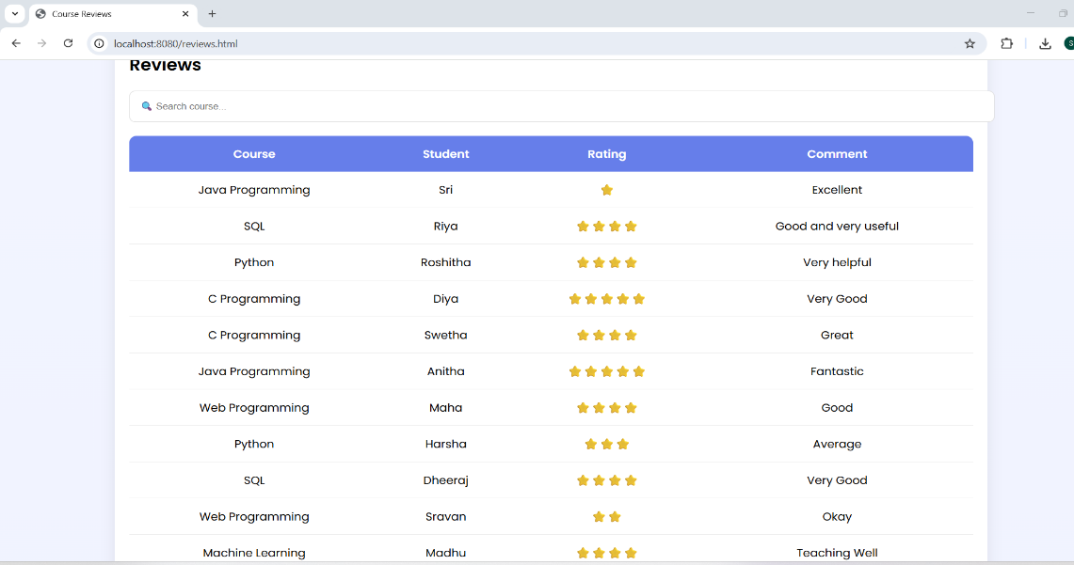
- Chart Analytics
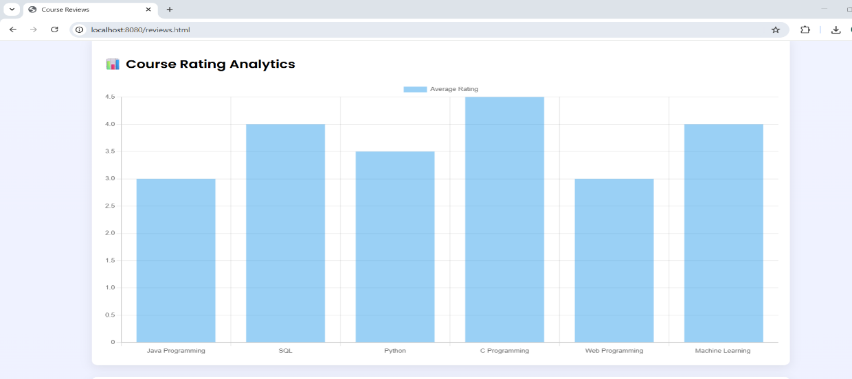

- Top Reviewers
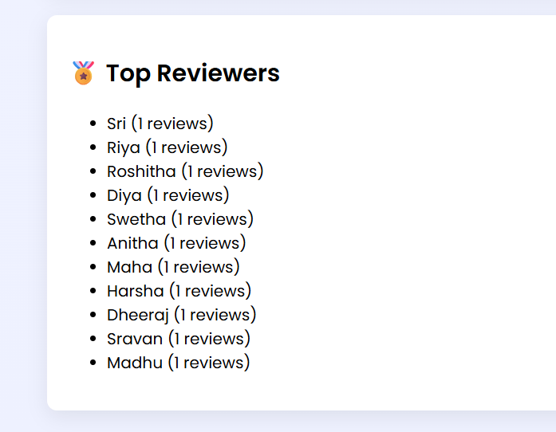

The Course Review Analyzer successfully provides a platform for collecting and analyzing course reviews. It improves decision-making for students and demonstrates practical implementation of full-stack development using Java and web technologies.

